Task of Cloud-Front
1) Configure VPC peering in cross regions.
Steps:
In Region 1 (us-east-1):
Go to VPC Console.
Click on Peering Connections > Create Peering Connection.
Enter:
Name tag: us-east-to-eu-west
VPC Requester: Select your VPC in us-east-1.
VPC Accepter: Choose "Another account or region", and then:
Account: Your AWS Account ID
Region: eu-west-1
VPC ID: Accepter VPC ID from eu-west-1
Created Vpc
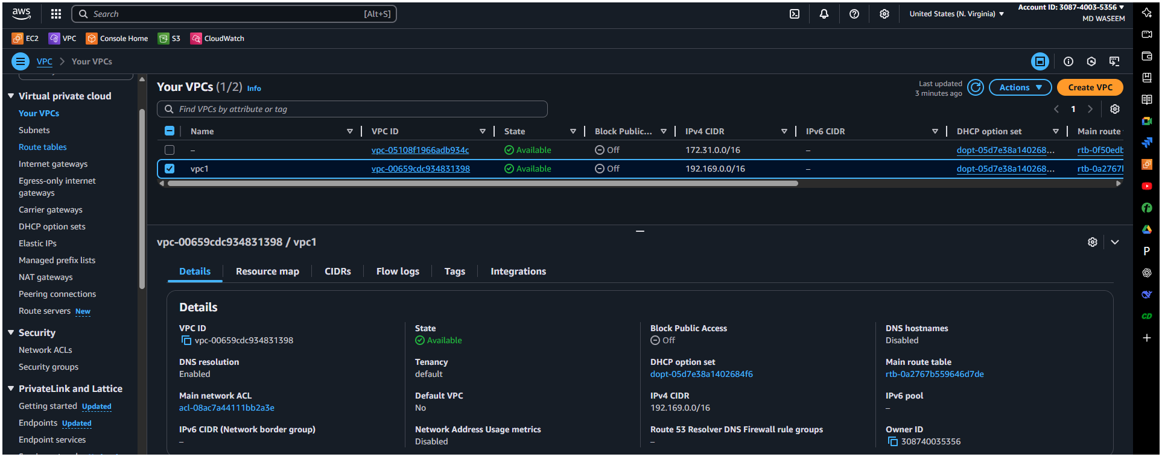
Subnet
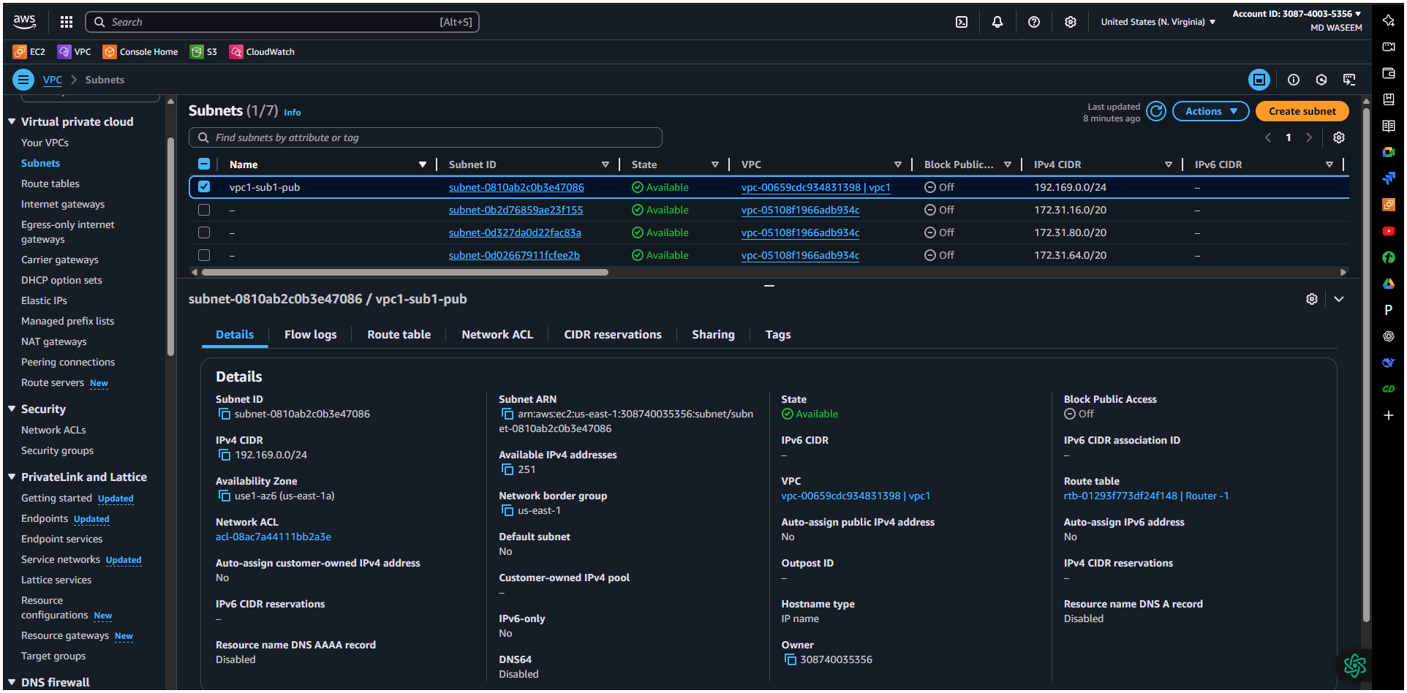
created Route Table
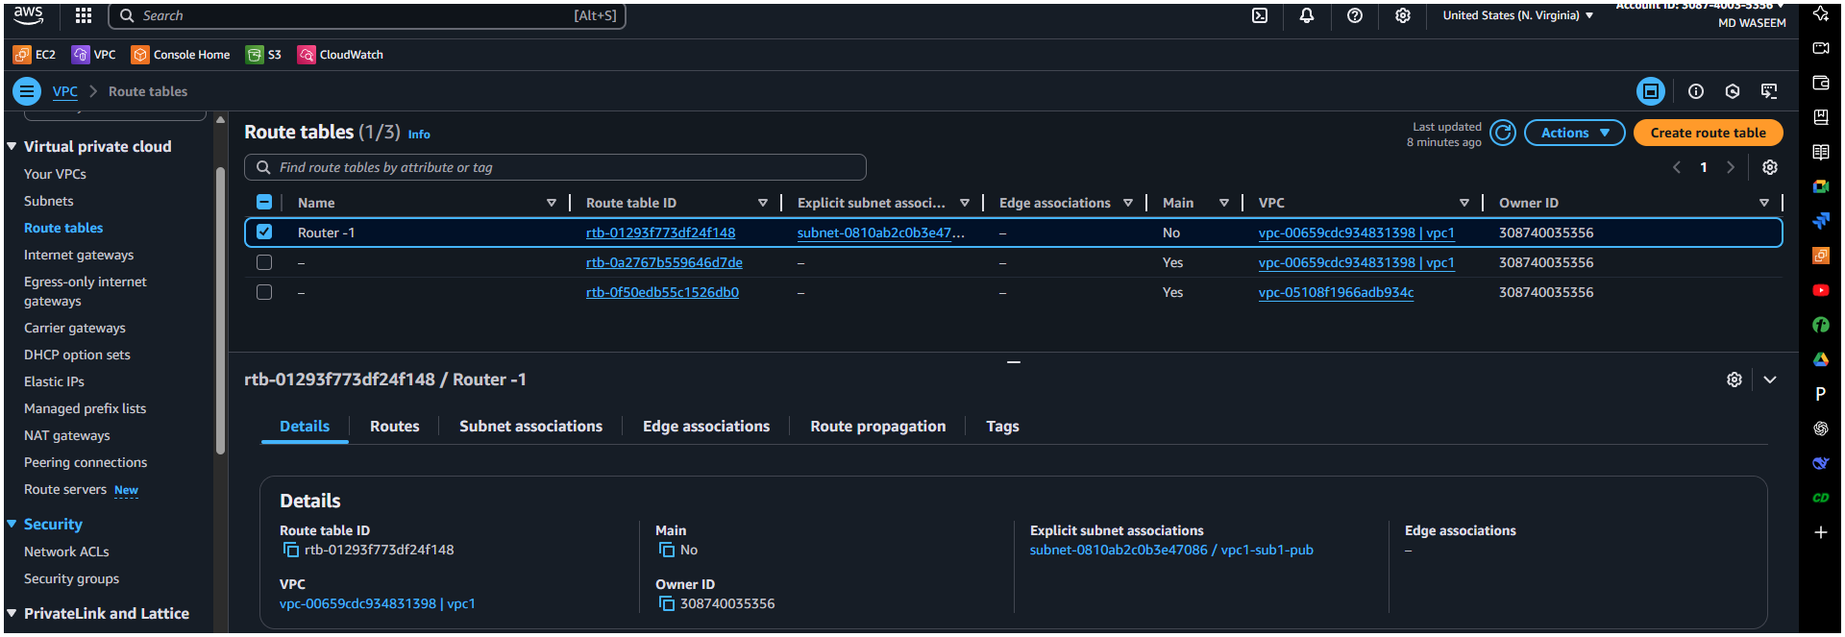
Internet Gatways
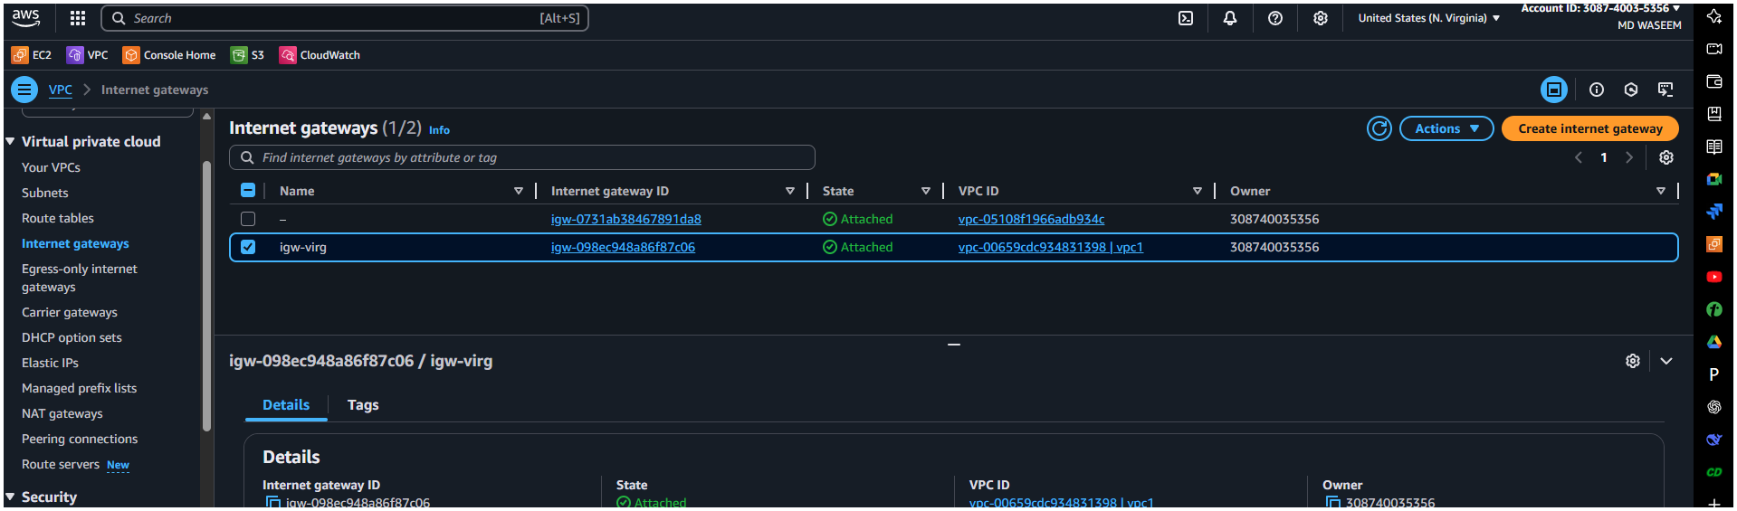
Requester Side
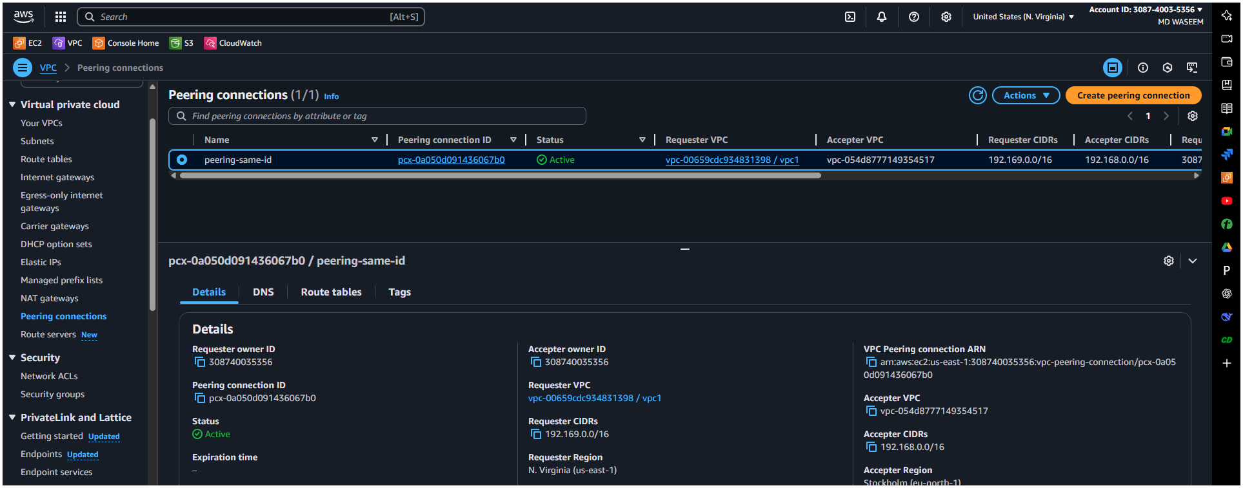
Click Create Peering Connection.
🔹 In Region 2 (Europe (Stockholm):
Go to VPC Console > Peering Connections.
Select the pending peering request.
Click Actions > Accept Request.
🔹 Update Route Tables in both VPCs:
Go to Route Tables > Choose the route table for each VPC.
Add a new route:
Destination: CIDR block of the other VPC.
Target: The VPC peering connection ID.
✅ Result: Now the two VPCs can securely communicate.
created Vpc from another region
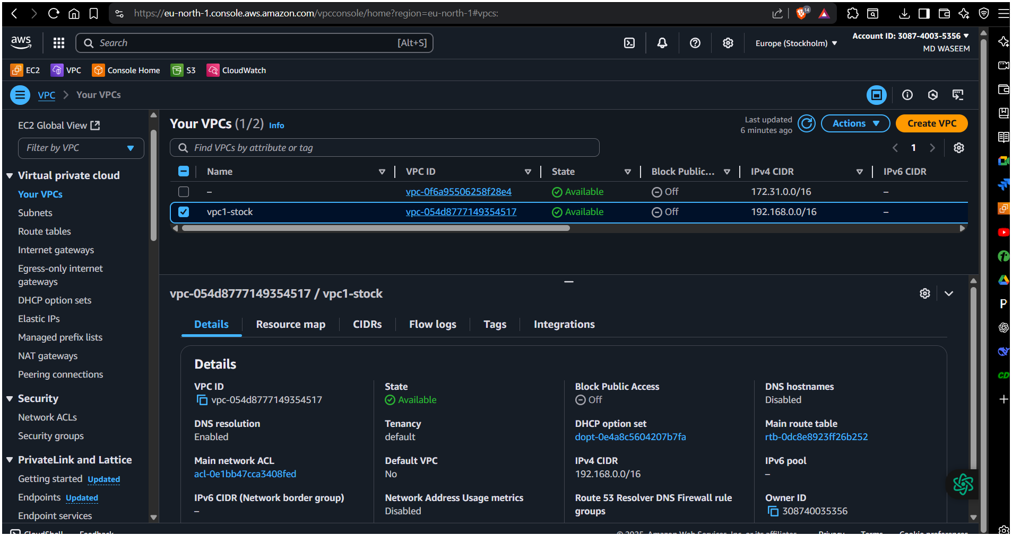
subnet
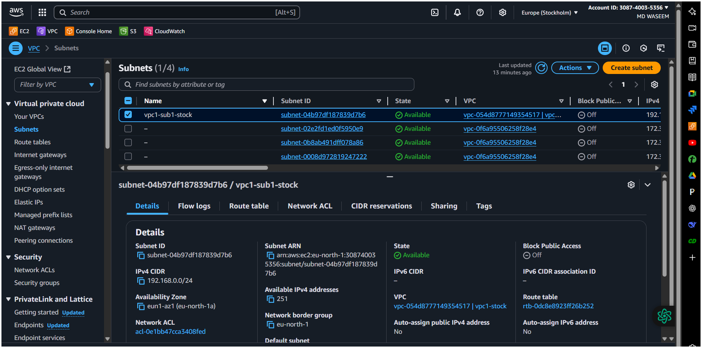
Route Table
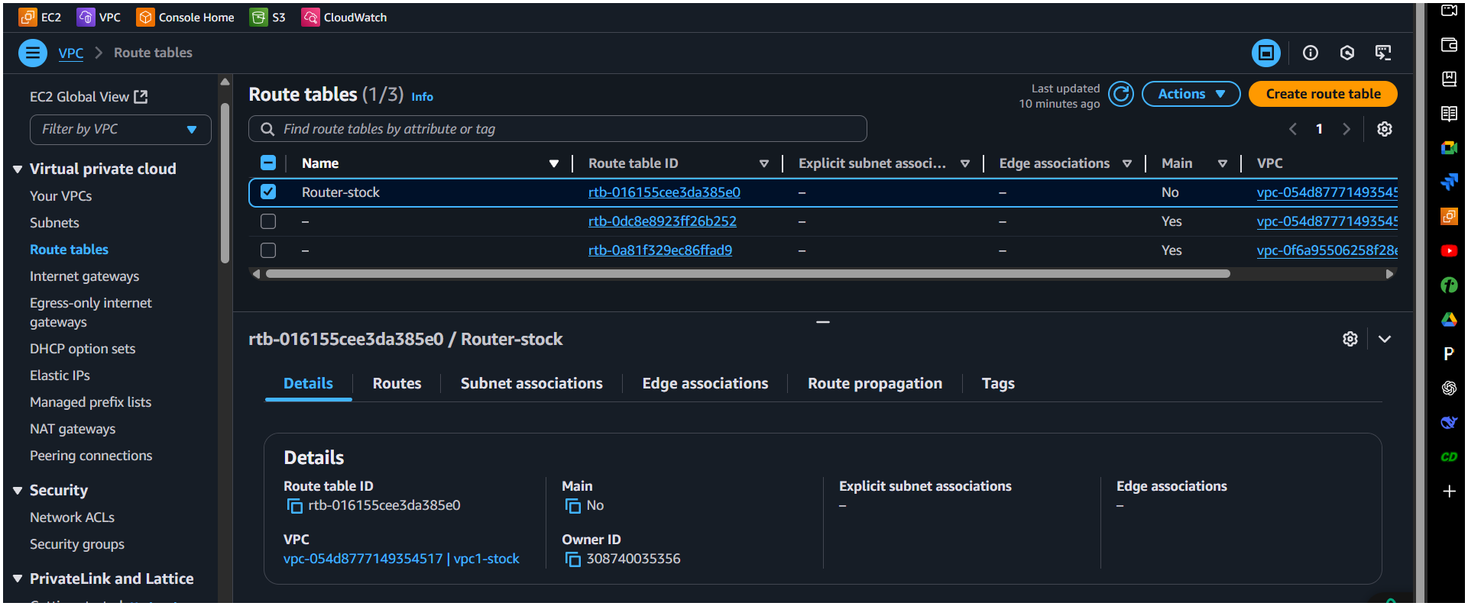
Internet Gatways
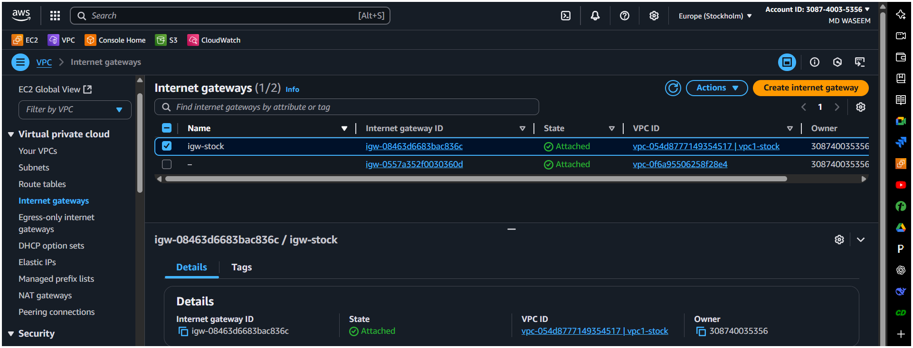
Accepter side
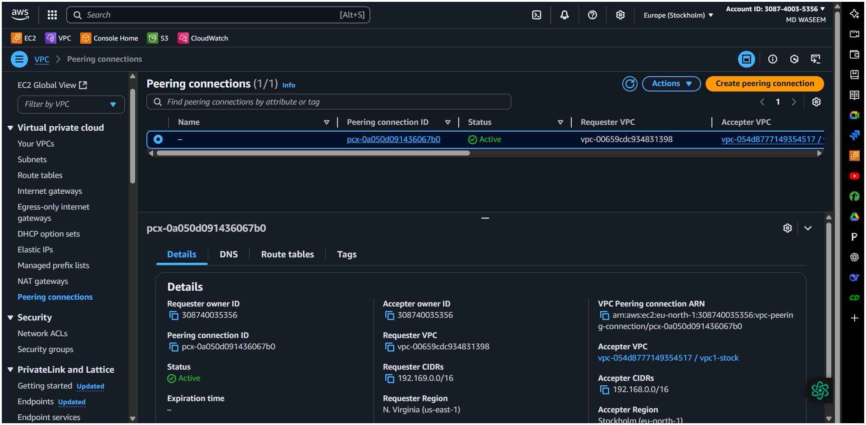

2) Purchase one domain from Crazy Domains.
3) Deploy static website in s3.
Host your website (HTML files) on Amazon S3.
📋 Steps:
Go to S3 Console > Create bucket:
Name: cloud-front-testingg -bucket
Region: Same as where you’ll host your content
Uncheck: “Block all public access”
Upload your index.html file.
Go to Properties > Enable Static Website Hosting:
Enable
Index document: index.html
Copy the S3 static website URL provided.
✅ Result: Your website is now available on an S3 public endpoint like:
You may get this error to overcome with we need to add this bucket policy
click your bucket then you get a option Permission Bucket policy Edit it Add this policy
{
"Version": "2012-10-17",
"Statement": [
{
"Sid": "PublicReadGetObject",
"Effect": "Allow",
"Principal": "*",
"Action": "s3:GetObject",
"Resource": "arn:aws:s3:::cloud-front-testingg/*"
}
]
}
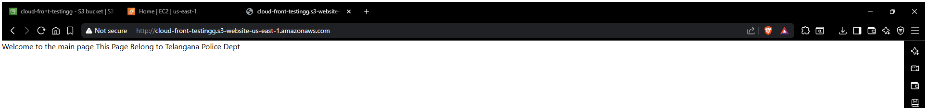
4) Create CDN and attach one SSL certificate.|
📋 Steps:
Request SSL Certificate:
Go to AWS Certificate Manager (ACM) > Request a certificate.
Choose: Request a public certificate.
Enter: mycoolwebsite.com
Choose DNS Validation.
It will give you a CNAME record to add.
Go to GoDaddy DNS Management > Add the CNAME.
Wait until it says Validated.
Create CloudFront Distribution:
Go to CloudFront Console > Create Distribution.
Origin:
Origin domain: Select your S3 bucket’s website endpoint.
Origin Access: Leave as is (for public bucket).
Viewer:
Alternate Domain (CNAME): mycoolwebsite.com
SSL Certificate: Choose the ACM certificate
Viewer Protocol Policy: Redirect HTTP to HTTPS
Create the distribution.
Wait ~10-15 minutes for the distribution to finish deploying.
✅ Result: Your site is now cached globally and accessible with HTTPS (SSL).
Creating CloudFront Distribution
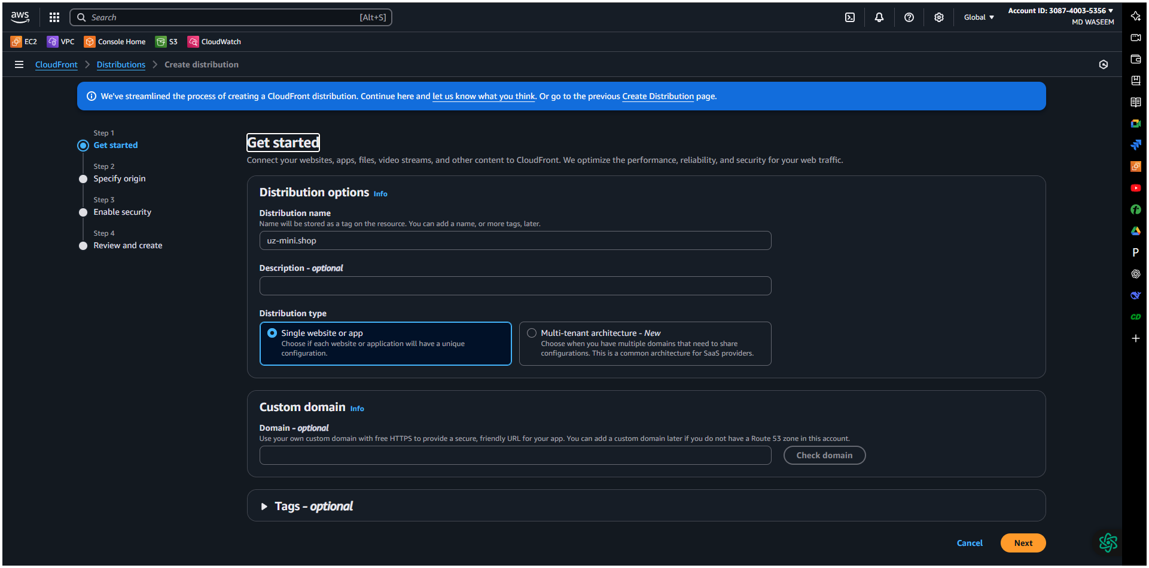
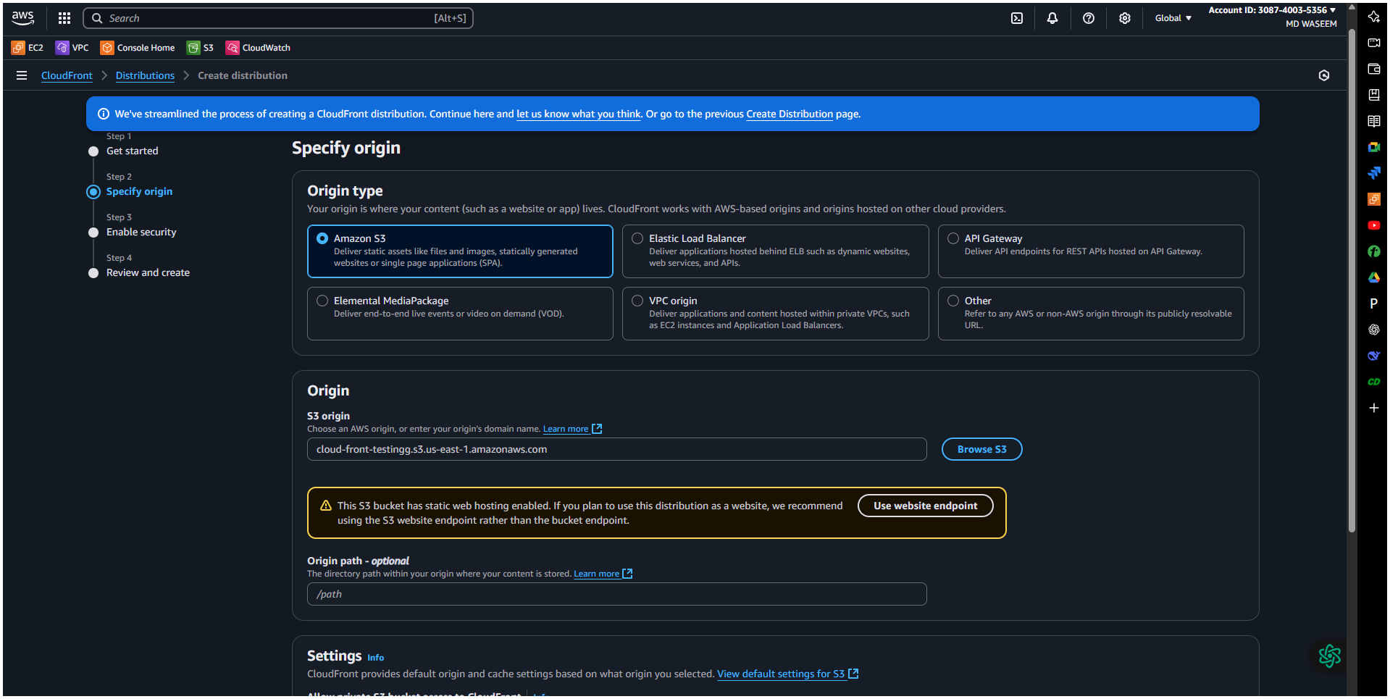
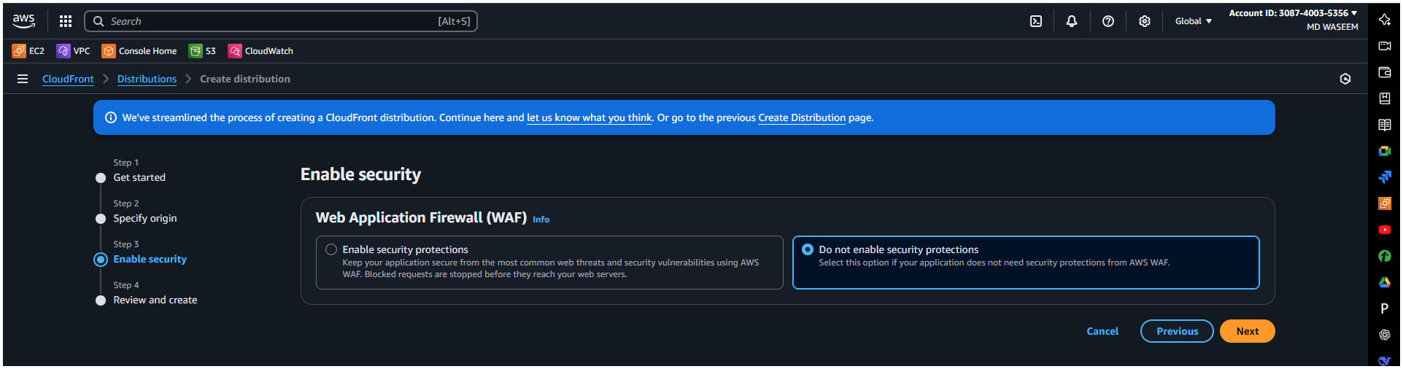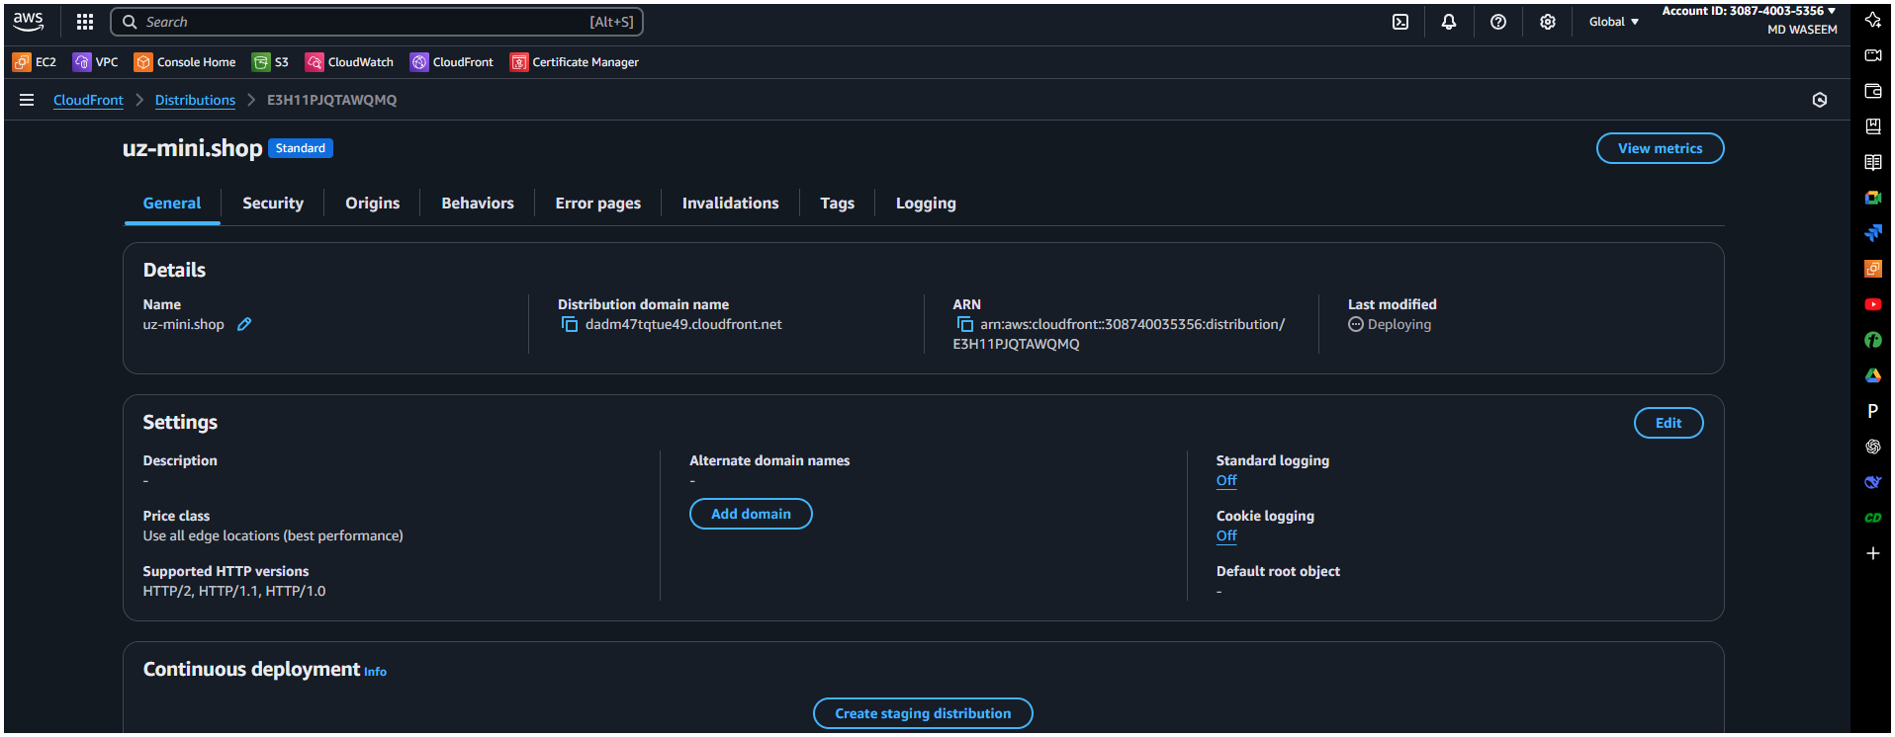
Go to your domain Dns setting add record select cname record Paste the cname , cvalues from your [Certificates manager from Aws console]
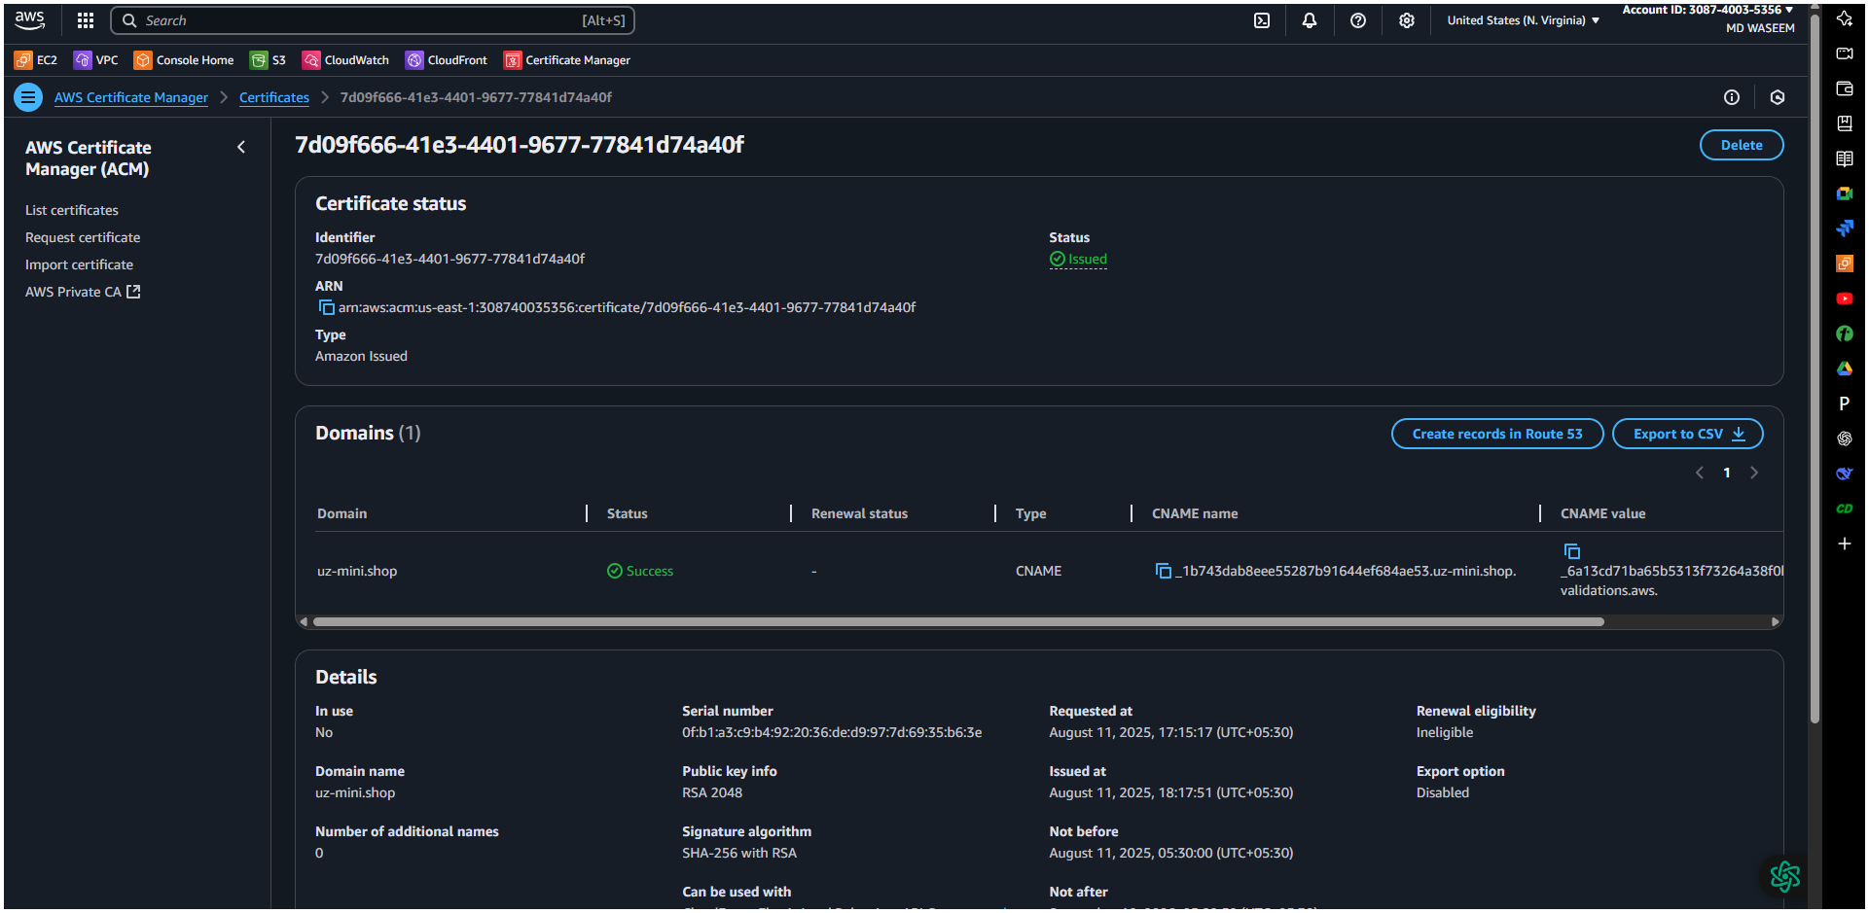
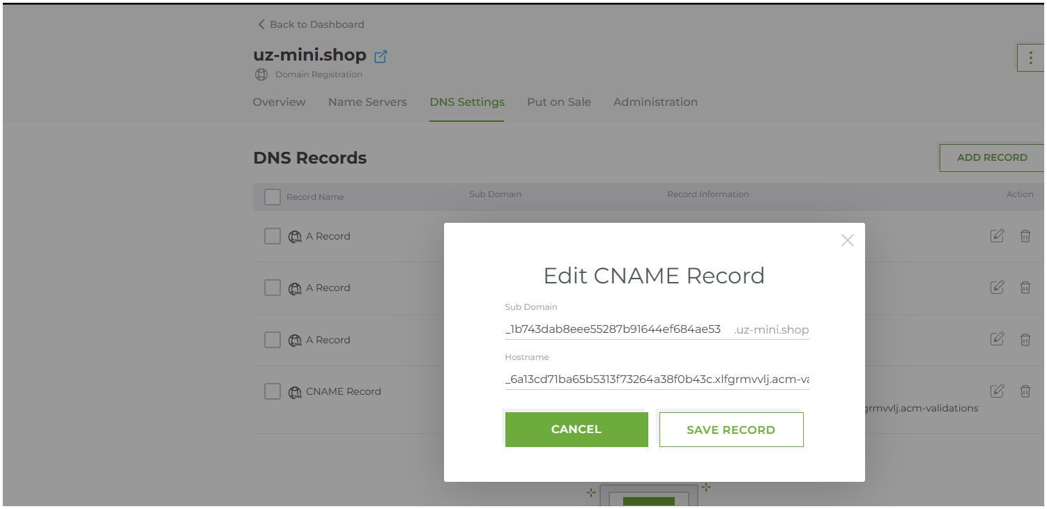
Added cname and cvalue in Domain DNS setting
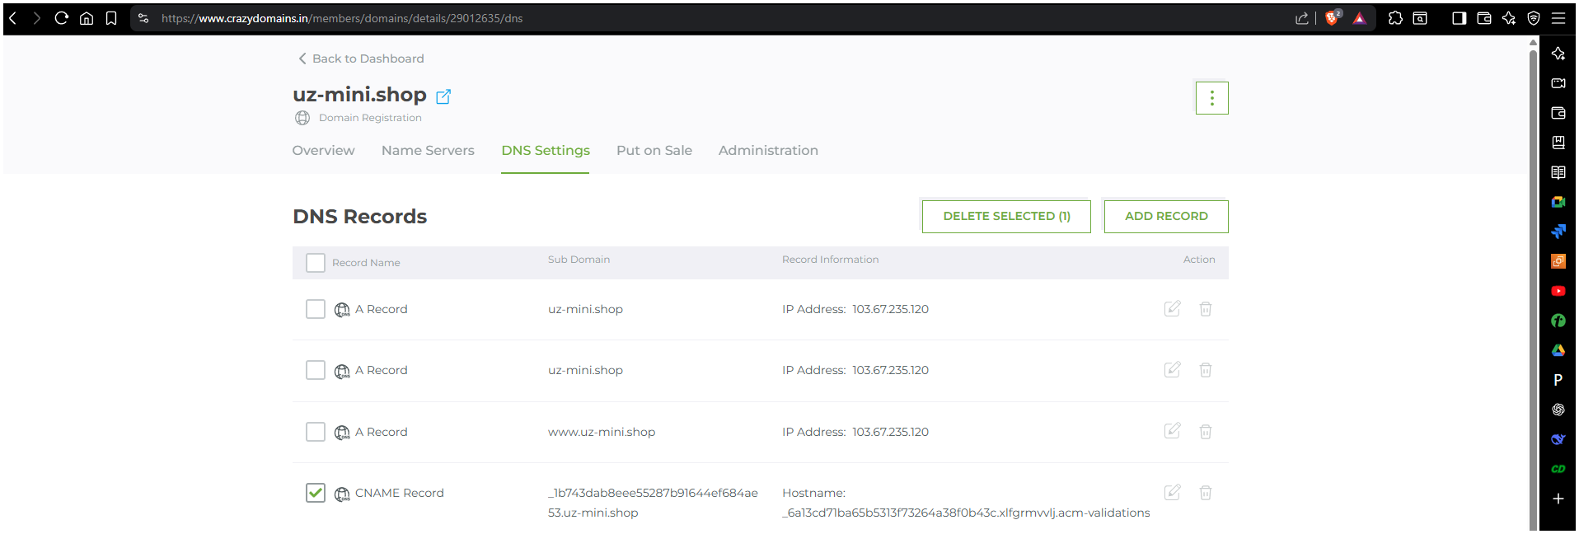
Certificate status check ✅
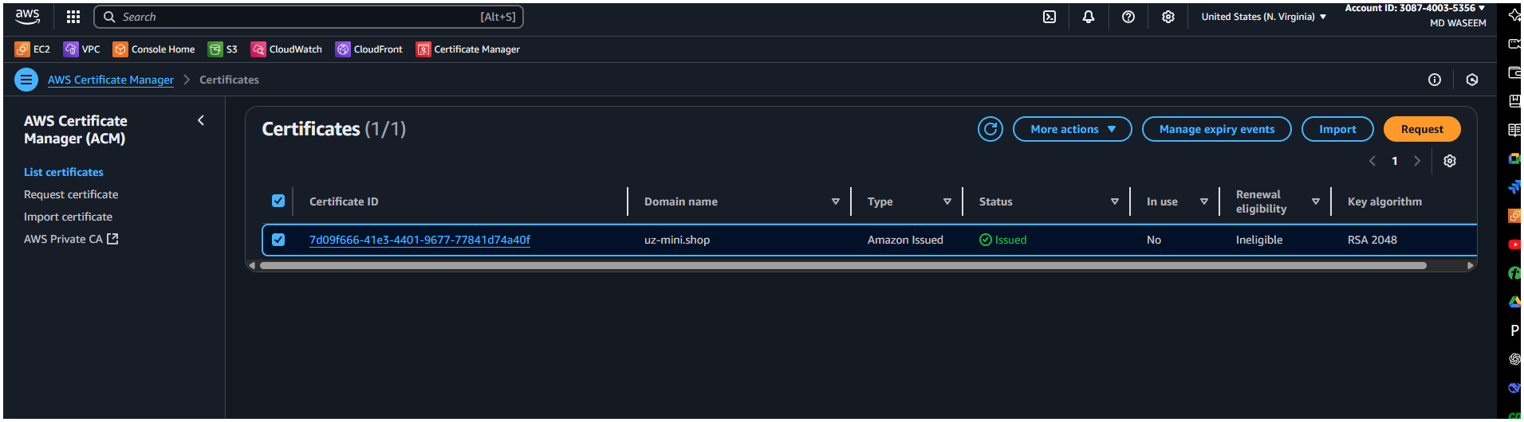

5) Create Route53 hosted zone and MAP the domain with CDN.
📋 Steps:
🔹 Create Hosted Zone:
Go to Route 53 Console > Hosted Zones > Create hosted zone:
Domain Name: mycoolwebsite.com
Type: Public Hosted Zone
Update GoDaddy Name Servers:
After hosted zone creation, copy the NS records (name servers).
Go to GoDaddy DNS > Change Nameservers > Set to custom.
Paste the four NS records from Route 53.
Create Record in Route53:
Inside the hosted zone:
Click Create Record:
Name: Leave blank (to use the root domain)
Type: A (Alias)
Value: Select your CloudFront distribution from alias target list
✅ Result: Now your domain (e.g., https://mycoolwebsite.com) points to your CloudFront.
Created Route-53
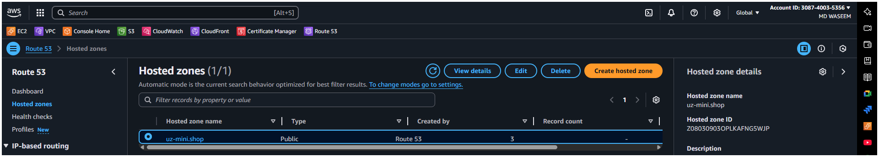
Add this NS {values/Routes traffic }
ns-497.awsdns-62.com
ns-879.awsdns-45.net
ns-1323.awsdns-37.org
ns-1636.awsdns-12.co.uk
------->copy this Name server name to your dns Name server
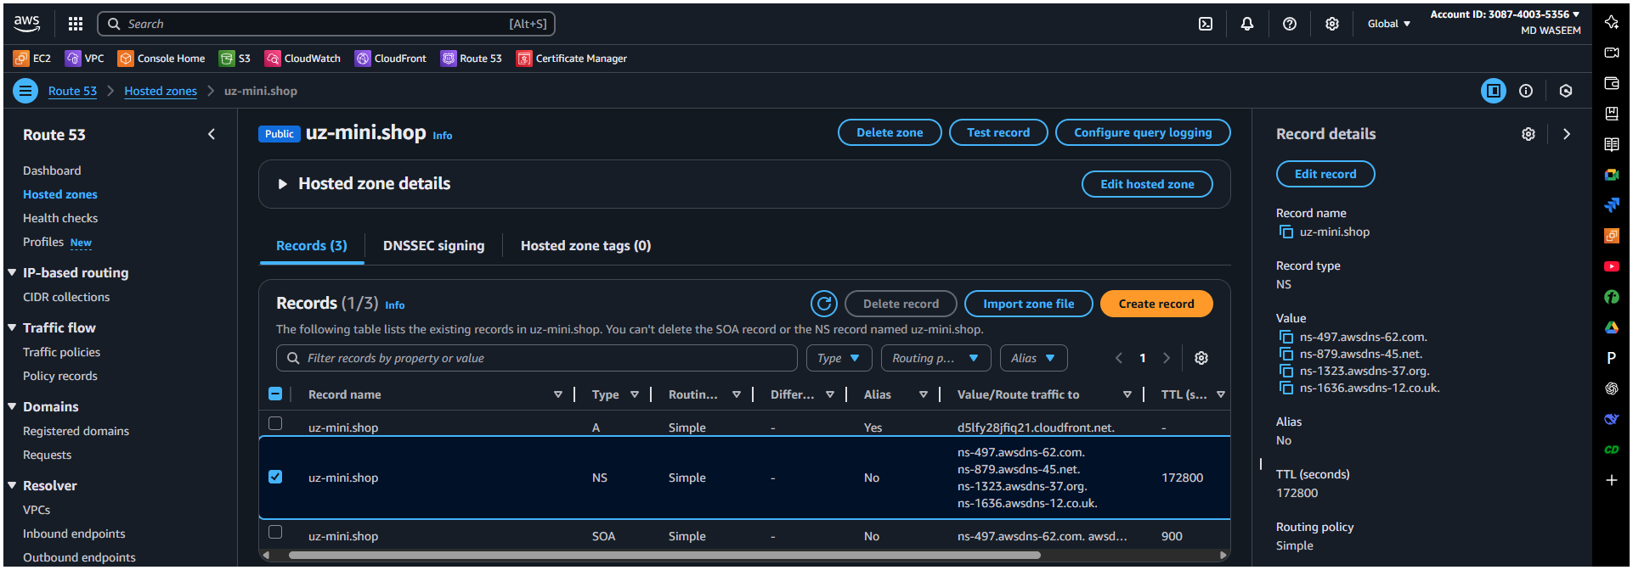
Here we are Tab the setting tab from the my-product segment/option
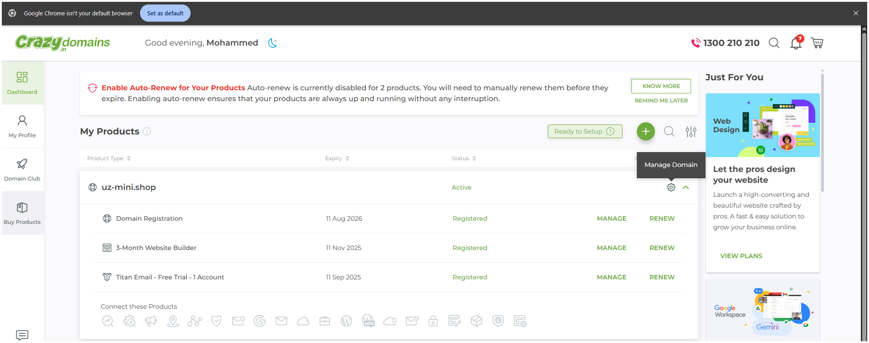
Here in Name servers select the 1st and click on the edit icon on the mid right
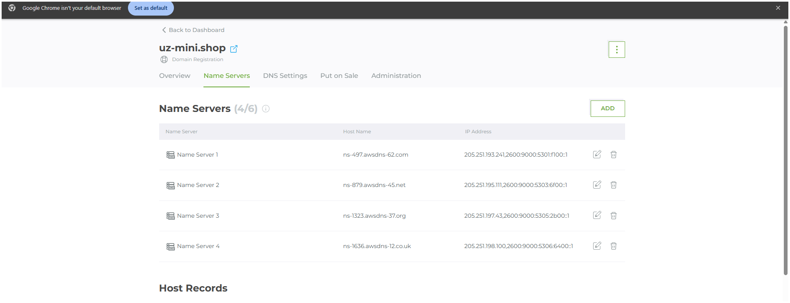
here we have add the Name server in Your Domain name {name server}
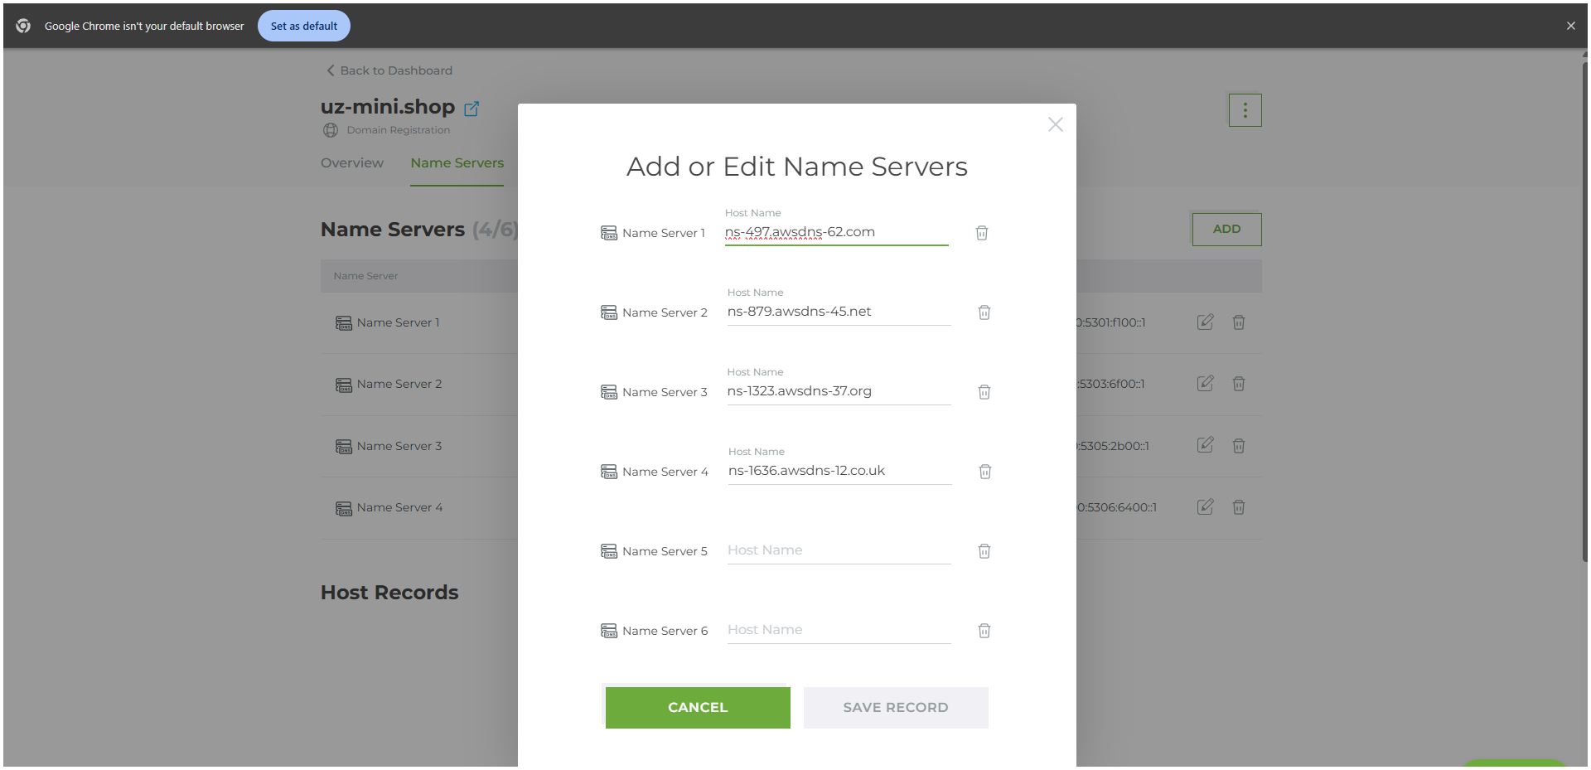
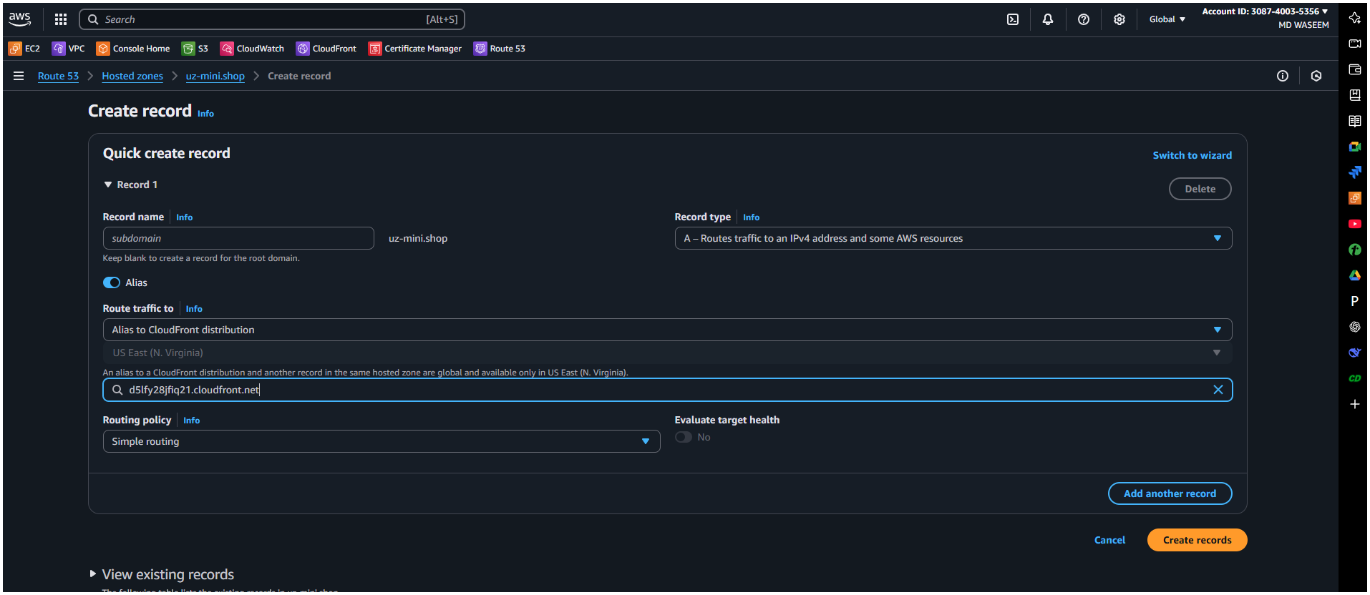
while adding the alternative and distribution from Cloud front
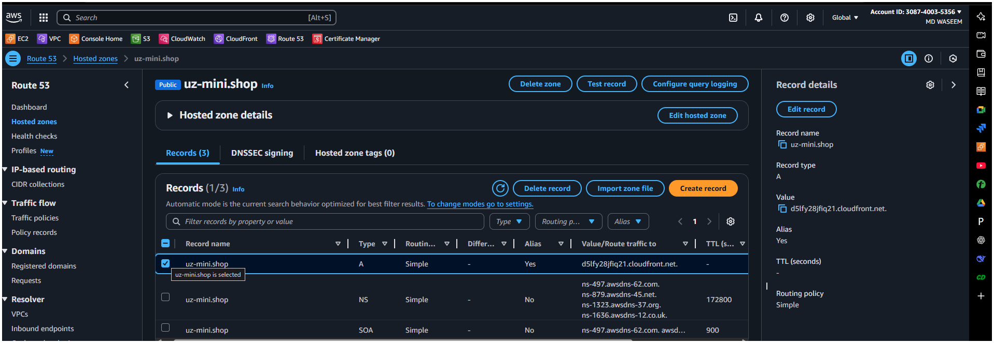
6) Update the index.html in s3 bucket and the updated file should be accessible by using domain name.
old file of test.html
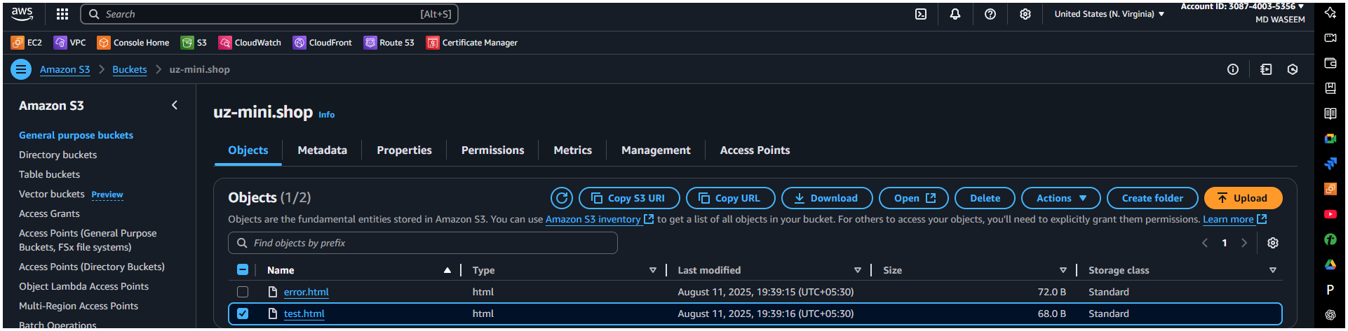
Run
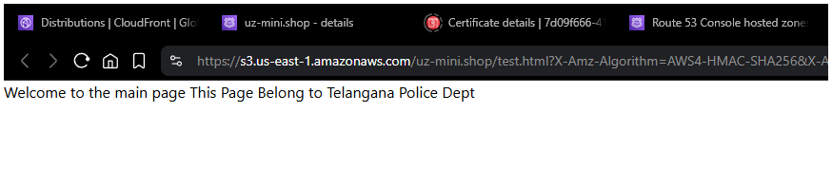

Overriding the Old with New Runed / Result
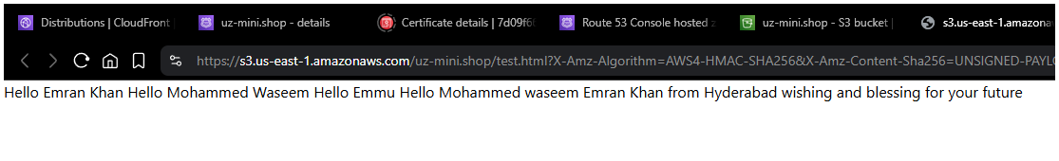
➤ In the CloudFront Console:
Go to your CloudFront distribution.
Click on the "Invalidations" tab.
Click "Create Invalidation".
In the Object Paths box, enter:

If you're not sure what changed or want to invalidate everything
Then simply add /*

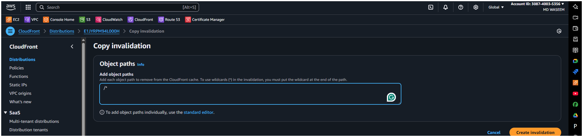
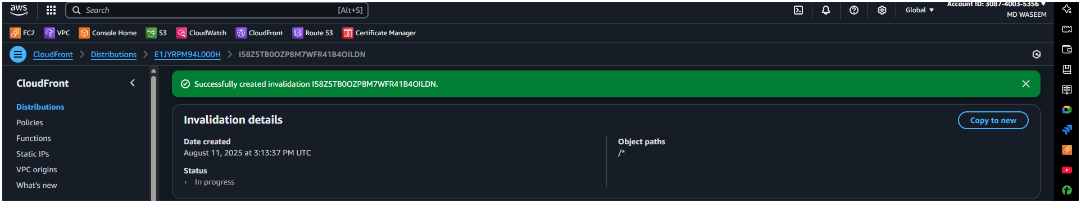
7) Share the Domain name in slack to test the connectivity.

